# OLAP vs. OLTP

**Online Transaction Processing (OLTP)** and **Online Analytical Processing (OLAP)** are two fundamental types of data processing systems used in databases and data warehouses.

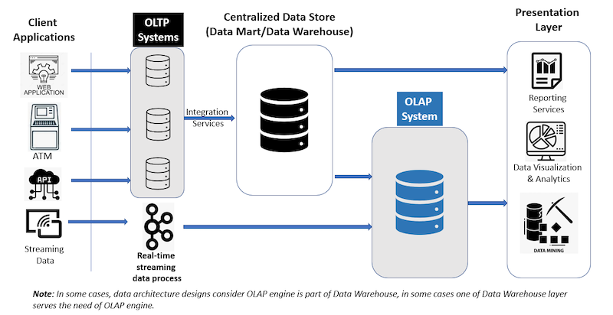**OLTP** focuses on managing real-time operational transactions, while **OLAP** is designed for complex analysis and decision-making based on historical data.

[1]

To provide a clear comparison, below is a table outlining the key differences across various aspects, based on established definitions and use cases from industry sources.

|  |  |  |
| --- | --- | --- |
| **Aspect** | **OLTP (Online Transaction Processing)** | **OLAP (Online Analytical Processing)** |
| **Purpose** | Handles day-to-day operational tasks, such as processing real-time transactions (e.g., bank withdrawals, e-commerce orders).[2][3] | Supports strategic decision-making through data analysis, reporting, and insights (e.g., sales trends over years).[4][5] |
| **Data Focus** | Deals with current, real-time data that is constantly updated; emphasizes accuracy and integrity for individual records. 4[6] | Works with historical, aggregated data from multiple sources; focuses on long-term patterns and summaries.[7][8] |
| **Query Type** | Simple, standardized queries (e.g., INSERT, UPDATE, DELETE) involving few records; optimized for speed in transactions. 6[9] | Complex, ad-hoc queries (e.g., aggregations, joins across large datasets) involving many records; may include multidimensional analysis. 25 |
| **Database Design** | Typically uses normalized relational databases (e.g., row-oriented storage) to minimize redundancy and ensure data consistency. 2[10] | Often employs denormalized structures like data warehouses or cubes (e.g., columnar storage, star/snowflake schemas) for efficient querying. 410 |
| **Performance** | High throughput for many small transactions; response times in milliseconds; prioritizes write operations and concurrency. 10[11] | Optimized for read-heavy operations; queries can take seconds to minutes due to large-scale aggregations. 510 |
| **Users** | Front-line employees, customers, or applications (e.g., cashiers, online shoppers); many concurrent users performing routine tasks. 9 | Analysts, managers, or executives (e.g., data scientists, business intelligence teams); fewer users but with advanced querying needs. 3 |
| **Data Volume** | Processes small amounts of data per transaction but handles high volumes of transactions overall. 911 | Deals with very large datasets (terabytes to petabytes) for comprehensive analysis. 711 |
| **Operations** | Frequent writes (inserts, updates, deletes) with some reads; requires strong ACID compliance for transaction integrity. 610 | Primarily read-only with batch updates; focuses on summarization and multidimensional views. 24 |
| **Examples** | Banking systems, retail POS, airline reservations. 2 | Business intelligence tools, sales forecasting, market research reports. 8 |

1. OLAP vs. OLTP | Key Differences | Blog | ByteHouse
2. OLAP vs. OLTP | Compare | aws.amazon
3. OLAP vs. OLTP | Key Differences | Fundamentals | Snowflake
4. OLAP vs. OLTP | Key Differences in DBMS | DBMS | GeeksForGeeks
5. OLAP vs. OLTP | Key Differences | Topics | Think | IBM
6. OLAP vs. OLTP | Key Differences | Resources | StitchData
7. OLAP vs. OLTP | Key Differences | Blog | DataCamp
8. OLAP vs. OLTP | Key Differences | Blog | Estuary
9. OLAP vs. OLTP | Key Differences | Questions | StackOverflow
10. OLAP vs. OLTP | Key Differences | Comments | DataEngineering | Reddit
11. OLAP vs. OLTP | Comparison | Blog | InerWorks